|  |
| --- |
| NAME : SHASHWAT SHAH  SAP ID : 60004220126  DIV : B3  EXPERIMENT 2 **:** System calls for file manipulation. |

Aim : System calls for file manipulation

**1.**

**pwd Command**

pwd, short for the print working directory, is a command that prints out the current

working directory in a hierarchical order, beginning with the topmost root directory

(

/

).

To check your current working directory, simply invoke the pwd command as

shown.

Command : $ pwd

**2.**

**mkdir Command**

You might have wondered how we created the tutorials directory. Well, it’s pretty

simple. To create a new directory use the mkdir ( make directory) command as

follows:

Command : $ mkdir directory_name

**3.**

**ls Command**

The ls command is a command used for listing existing files or folders in a

directory. For example, to list all the contents in the home directory, we will run the

command.

Command : $ ls

**4.**

**cd Command**

To change or navigate directories, use the cd command which is short for change

directory.

For instance, to navigate to particular directory run the command:

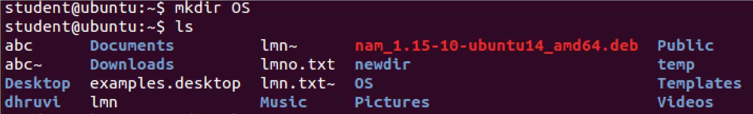

Command : $ cd directory_name

**5.**

**rmdir Command**

The rmdir command deletes an empty directory. For example, to delete or remove

the tutorials directory, run the command:

Command : $ rmdir OS

**6.**

**touch Command**

The touch command is used for creating simple files on a Linux system. To create

a file, use the syntax:

Command : $ touch filename

For example, to create a file1.txt file, run the command:

$ touch file1.txt

7.

**cat Command**

To view the contents of a file, use the cat command as follows:

Command : $ cat filename

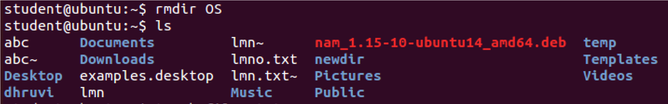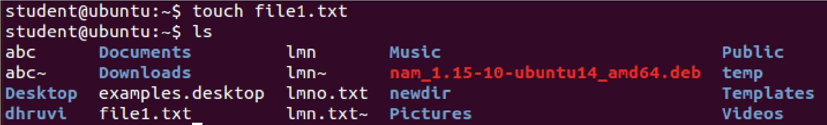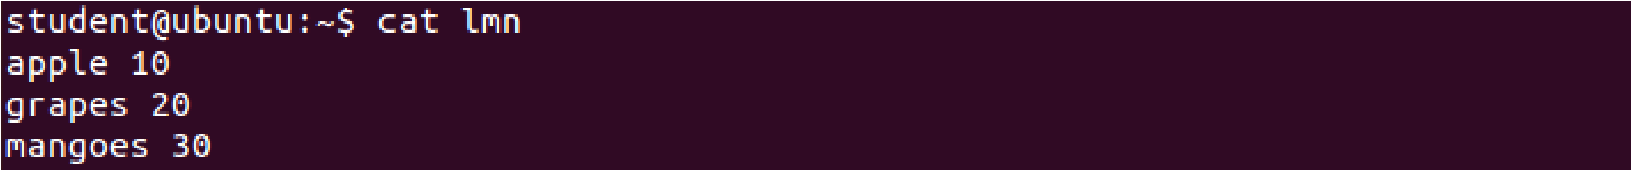

|  |  |
| --- | --- |
| **8.mv Command**  The mv command is quite a versatile command. Depending on how it is used, it can rename a file or move it from one location to another.  To move the file, use the Command below:  $ mv filename /path/to/destination/    **9. cp Command**  The cp command, short for copy, copies a file from one file location to another. Unlike the move command, the cp command retains the original file in its current location and makes a duplicate copy in a different directory.  The Command for copying a file is shown below.  $ cp /file/path /destination/path | |
|  |  |
| **10. Deleting a File**  rm command could be used to delete a file. It will remove the filename file from  the directory.  Command : $rm file_name |

Conclusion :

Hence all the commands for system call

for

manipulation were understood and performed .

